Volunteer Online Background Check
Instruction Guide

The Office for the Protection of Children and Young People (OPCYP) would like to welcome you as a new volunteer to the Diocese of Arlington. The Diocese requires that all volunteers with substantial contact with children must complete the Online Background Check Application prior to volunteering as part of their compliance. Your continued volunteer service is conditioned upon completing the application and passing all background checks. The online application should take you approximately 25 minutes to complete.

Information Needed To Complete The Online Background Check:

- Social Security Number or Individual Taxpayer Identification Number
- Driver’s license or state issued ID information
- Your address history for the last 15 years
- Employment history for the last 5 years of employment (If you have worked for the same company for the past five years, please provide at least one other employer if possible. If you were a student, provide the school information.)
- Location [Sacred Heart Academy] and Position Title indicated in your Welcome Letter
- Application Type: Volunteer
- Position Title: Volunteer General
Family Information for CPS: Children’s Full Legal Name and Date of Birth
- Criminal history information (i.e., charges/convictions, jurisdiction, approximate date)

Follow Steps to Begin the Online Background Application:
Step 1: Use the following URL to log into the OPCYP Background Check Application site:

https://secure4.arlingtondiocese.org/OPCYP_Application/

Step 2: If you are a NEW USER, choose “Create Account.”
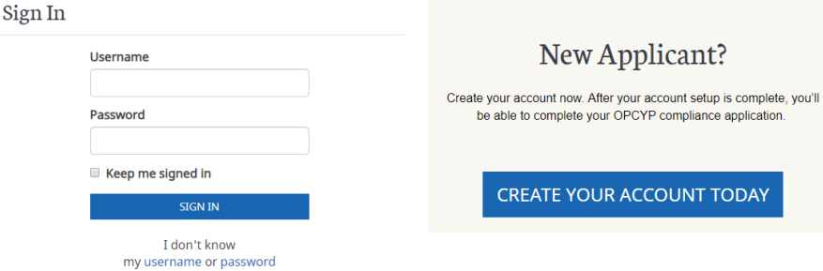
RETURNING USERS will sign in on the left-hand side. Provide your username and password.

Error message: ssn/iten is already in use
If the SSN/ITEN number is already in the diocesan database, the following error message displays:
Contact https://OPCYPSupport.freshdesk.com for assistance.

Step 3: Complete each section of the online background check application and answer the questions as thoroughly as possible. Fields with an * are required fields. Use your legal name.
- Applicant Information
- Personal Information
- Criminal Information
- Employment/Volunteer History

Step 4: Once you have completed the application, press the “Finish” button to proceed to the electronic signing of your forms.

STOP! Please Read Instructions Before Continuing

Review of Forms Process
The information that was collected during the application process has now been loaded into the Diocesan and State of Virginia forms. Please,
- Review the forms for accuracy. If you find errors, decline to sign the forms, return to the application and log back into your account. Select “edit” to make the needed changes, and then resubmit your application. The DocuSign email will recreate your forms for signature.
- Provide your electronic signature that states that you have received or read the documents.
- Complete the process by clicking finish once you have reviewed and signed the documents.
- Print or save an electronic copy of the full Child protection Policy and Code of Conduct for your information.
- DocuSign will electronically send your signed forms to your Liaison for their review.

Next Steps
Now that you have completed the application process, this is what you should expect:
- The OPCYP Liaison will be reviewing your paperwork to ensure all the information has been correctly entered. If there is a question or an issue with your paperwork an email will be sent with instructions explaining the issue(s) and the next steps.
- The OPCYP Liaison will be contacting you shortly to invite you to meet, sign and notarize the Child Protective Services Central Registry Release of Information form at the location. Please work with them to set-up a mutual time to complete the process.
- Please keep your Username and Password in a safe place.

Nota Bene
The Diocese of Arlington is committed to ensuring the privacy and security of your information. It does not sell or share its information with outside vendors. To this end, regular electronic audits are conducted on our systems to provide you with the utmost confidence that your information is being securely stored and used appropriately.

